Bengaluru, Karnataka, India


AN INTERNSHIP REPORT ON

“ ENGINEERING SGPA/CGPA CALCULATOR”

BACHELOR OF ENGINEERING
In

COMPUTER SCIENCE AND ENGINEERING

Submitted by

SANJAY D HEBBAR (1KS16CS085)



K.S. INSTITUTE OF TECHNOLOGY

(Affliliated to VTU , Belagavi & Approved by AICTE, New Delhi, Accredited by NAAC &IEI)
BANGALORE , KARNATAKA 560002
2021-2022

ABOUT THE COMPANY

CST is a digital service provider that aims to provide software, designing and marketing solutions to individuals and businesses. At CST , we believe that service and quality is the key to success
We provide all kinds of technological and designing solutions from Billing Software to Web Designs or any custom demand that you may have. Experience the service like none other!

Some of our services include:
- Development - We develop responsive, functional and super-fast websites.
- We keep User Experience in mind while creating websites. A website should load quickly and shouldbe accessible even on a small view-port and slow internet connection.
- Mobile Application - We offer a wide range of professional Android, iOS& Hybrid app development services for our global clients, from a start up to a large enterprise.
- Design - We offer professional Graphic design, Brochure design & Logo design. We are expertsin crafting visual content to convey the right message to the customers.
- Consultancy - We are here to provide you with expert advice on your design and development requirement.
- Videos - We create a polished professional video that impresses your audience.

Table of Contents

Contents Page No.

Table of Contents I
Overview of the project 1
About 2
Tools used 3
Implementation 4-25
Snapshots 26-27
Biblography 28

(I)

OVERVIEW OF THE PROJECT

Project Name: Engineering SGPA/CGPA Calculator
Team Members: SANJAY D HEBBAR

This project is based on Web Development and its Applications. The main objective of this project is to learn the implementation of HTML, CSS and JavaScript at frontend and PHP, MySQL database at backend, The webpage of this project is created using HTML and styling of the webpage is done using CSS.

It is a web application that simplifies the task of storing a users results . The system is flexible to be used and reduces the need of frequently searching and accessing an individuals marks. The system is developed to provide an easy means for storing semester wise results. Individuals have to login and enter their marks in a form.They can then access the result and print it in a PDF format.

- USER MODULE
This module is mainly dedicated to the candidates who are looking to store their result. They can log in into the system, via the credentials provided to them & once they are in, they have to enter their data by filling an online form . They can download the result from the same module, in PDF file format.

- ADMIN MODULE
This module is maintained by the admin and only he/she can manage and have access to every account. Admin can add or delete the users as well. They can modify the functionalities of the system, too. Admin can also add users on the fly to the application to make the application full of new functionalities.

SGPA Calculator

OVERVIEW and Details

CGPA refers to the cumulative grade point average which literally translates
to the sum total of all your credit points. This system helps in assessing the
overall academic performance of a student. Although the evaluation criteria
may vary from one country to another, the CGPA system is among the most
common evaluation way in most professional/technical courses.

Key details on SGPA and CGPA:

How do you Calculate SGPA?

SGPA, which stands for Semester Grade Point Average is an evaluation method that
highlights the semester wise performance of the student. It can be calculated by
simply adding all the credit points awarded for the subjects and then dividing it by the
total credits allotted to that semester.
For example, in a total of 3 subjects, you scored the following grade points:

Subject 1: 8
Subject 2: 6

Subject 3: 7

The total credit for each subject is 10.
1. Now, first we will multiply, the grade point with the total credit point for each
subject: Subject 1: 8*10 = 80
Subject 2: 6*10 = 60
Subject 3: 7*10 = 70
2. To calculate SGPA here, you need to add all these grade points and then divide it
by the total credits, i.e.
Total grade points: 210
Total credits: 30
To get SGPA, divide grade points by total credits,
=210/30
=7 SGPA

How to Find CGPA from SGPA?

To find CGPA from SGPA, you need to follow this formula:
CGPA= (SGPAs of All semesters in an academic year)/ Number of semesters

Thus, by adding up all the SGPAs you have got in an academic year by the total

number of semesters, you will find CGPA from SGPA.
For example,
Suppose that you scored 7 SGPA and 9 SGPA in your two
semesters. 1. First you need to add both these SGPAs.

2. Then, divide the total SGPA with the number of semesters, i.e.
2. Your CGPA would be:
CGPA = SGPA of all semesters in a year/Number of semesters
= (7+9)/2
= 8 CGPA

Structural and Conceptual Framework:
The website should be easy to use and should be user-friendly. It should be
compatible with mobile phones and other devices. Also, the data of the user should
be completely secured and (s)he has to make an account and set their password to
access their account at any point in time, the content of the web page should be
downloadable in pdf format
Structural and Conceptual Planning:
● Conversion of current web page content into PDF format.
● User Input(credits available as per the University’s guidelines)
● Making sure to use the Information above to build a logical approach towards
the Client requirements
● Encrypting passwords for user privacy(if optional)
● Making a website compatible to use on other devices.

TOOLS USED

Software Requirements

  - Visual Studio Code 2019.

  - Google Chrome or Microsoft Edge of latest version.

  - Front End: HTML, CSS, JS

  - Backend : Php, MySQL, Xampp

  - Linux 7.1 or Windows XP/7/8/10 OS or Mac OS

Hardware Requirements

  - Pentium 200-MHz computer with a minimum of 64 MB of RAM (128 MB of RAM recommended).
  - Monitor with a refresh rate of at least 40Hz for a smooth GUI experience (optional).

IMPLEMENTATION

app.js - javascript

const result = document.getElementById('calculate');
const pointer = document.getElementById('pointer');
const mes = document.getElementById('message');

const credits = {
osTheory: 3,
osPractical: 1,
tocTheory: 4,
m4Theory: 4,
seTheory: 3,
sePractical: 1,
dbmsTheory: 4,
dbmsPractical: 1,
cl3Practical: 1,
seminarPractical: 1
}

const {
osTheory,
osPractical,
tocTheory,
m4Theory,
seTheory,
sePractical,
dbmsTheory,
dbmsPractical,
cl3Practical,
seminarPractical
} = credits;

function grade(g) {
if (g == 'A+')
return 10;
else if (g == 'A')
return 9;
else if (g == 'B+')
return 8;
else if (g == 'B')
return 7;
else if (g == 'C+')
return 6;
else if (g == 'C')
return 5;
else if (g == 'D')
return 4;
else return 0;
}

result.addEventListener('click', function () {

const m4th = document.getElementById('m4th').value,
osth = document.getElementById('osth').value,

tocth = document.getElementById('tocth').value,
dbmsth = document.getElementById('dbmsth').value,
seth = document.getElementById('seth').value,
sempr = document.getElementById('sempr').value,
cl3pr = document.getElementById('cl3pr').value,
ospr = document.getElementById('ospr').value,
sepr = document.getElementById('sepr').value,
dbmspr = document.getElementById('dbmspr').value;

if (osth === 'Theory' || ospr === 'Practical') {
showOutputOnUI(-1);
} else {
const calculate = ((grade(osth) * osTheory) +
(grade(ospr) * osPractical) +
(grade(tocth) * tocTheory) +
(grade(seth) * seTheory) +
(grade(sepr) * sePractical) +
(grade(dbmsth) * dbmsTheory) +
(grade(dbmspr) * dbmsPractical) +
(grade(m4th) * m4Theory) +
(grade(sempr) * seminarPractical) +
(grade(cl3pr) * cl3Practical));
const sgpa = calculate / 23;
const calulatedsgpa = parseFloat(sgpa).toFixed(2);
showOutputOnUI(calulatedsgpa); }
});

function showOutputOnUI(sgpa) {

if (sgpa == -1) {
mes.innerHTML = `Please, Select proper Grade`;
animate(mes, 'heartBeat');
pointer.innerHTML = '';
animate(pointer, 'rubberBand');
} else {
let message = '';
mes.innerHTML = message;
animate(mes, 'flipInY');
pointer.innerHTML = sgpa +
`<span class="outof">/10</span>`;
animate(pointer, 'wobble');
}
}

function animate(element, animation) {
element.classList.add('animated', animation);
const wait = setTimeout(() => {
element.classList.remove('animated', animation);
}, 1000);
}

document.oncontextmenu = function () {
return false;

}

document.onkeydown = function (event) {

if (event.which == 123)
return false;
else if (event.ctrlKey && event.shiftKey && event.keyCode == 73)
return false; else if (event.ctrlKey && event.which == 85)

return false;
}

Style.css

body {
background-repeat: no-repeat;
background-size: cover;
background-position-y: -80px;
/* background-attachment: fixed; */
font-family: 'Tomorrow', sans-serif;
}

#box {
max-width: 700px;
opacity: 0.93;
}

footer a {
text-decoration: none !important;
color: #a19d9d !important;
}

.outof {
font-family: Nunito Sans;
font-size: 1rem;
font-weight: 400;
margin-left: .5rem;
color: #7c95aa;
}
.faint-color {
color: #7c95aa;
}

Index.html

<!DOCTYPE html>
<html lang="en">
<head>
<!-- Global site tag (gtag.js) - Google Analytics -->
<script async src="https://www.googletagmanager.com/gtag/js?id=UA-152436258-1"></script>
<script>
window.dataLayer = window.dataLayer || [];

function gtag(){dataLayer.push(arguments);}
gtag('js', new Date());

gtag('config', 'UA-152436258-1');
gtag('event', 'click', {
'event_label': 'Calculate',
'event_category': 'Calculate Sgpa'
});
</script>

<meta charset="UTF-8">
<meta name="viewport" content="width=device-width, initial-scale=1.0">
<meta http-equiv="X-UA-Compatible" content="ie=edge">
<meta name="google-site-verification" content="MNzal0eBD7OcBcZi6xQjLhd3LjcyEUDJc-i5DmOj5JA" />
<link rel="stylesheet" href="https://stackpath.bootstrapcdn.com/bootstrap/4.4.1/css/bootstrap.min.css"
integrity="sha384-Vkoo8x4CGsO3+Hhxv8T/Q5PaXtkKtu6ug5TOeNV6gBiFeWPGFN9MuhOf23Q9Ifjh" crossorigin="anonymous">
<link href="https://fonts.googleapis.com/css?family=Tomorrow&display=swap" rel="stylesheet">
<link rel="stylesheet" href="https://cdnjs.cloudflare.com/ajax/libs/animate.css/3.7.2/animate.min.css">
<meta content="Calculate Semester-V{IT, SGGIE&T} SGPA " name=description>
<link rel="stylesheet" href="style.css">
<title>SGPA calculator</title>
</head>

<body>
<div class="container animated swing bounceIn mt-5 mb-3 ">
<div class="text-center text-light">
<h1>SGPA Calculator</h1>
<p>Calculate Semester-V SGPA </p>
</div>

<div id="box" class="mx-auto bg-white px-sm-5 pt-sm-5 pb-sm-1 p-4 mt-3 rounded">
<div class="row ">
<div class="col-sm-6">
<h5>Operating System</h5>
</div>
<div class="col-sm-3 ">
<div class="form-group">
<select class="form-control" id='osth'>
<option selected="selected">Theory</option>
<option>A+</option>
<option>A</option>
<option>B+</option>
<option>B</option>
<option>C+</option>
<option>C</option>
<option>D</option>
<option>F</option>
</select>
</div>
</div>
<div class="col-sm-3 mt-sm-0 mt-1">
<div class="form-group">
<select class="form-control" id='ospr'>
<option selected="selected">Practical</option>
<option>A+</option>
<option>A</option>
<option>B+</option>

<option>B</option>
<option>C+</option>
<option>C</option>
<option>D</option>
<option>F</option>
</select>

</div>
</div>
</div>

<div class="row mt-sm-2 mt-0">
<div class="col-sm-6">
<h5>Theory Of Computation</h5>
</div>
<div class="col-sm-6">
<div class="form-group">
<select class="form-control" id='tocth'>
<option>A+</option>
<option>A</option>
<option>B+</option>
<option>B</option>
<option>C+</option>
<option>C</option>
<option>D</option>
<option>F</option>
</select>
</div>
</div>
</div>
<div class="row mt-sm-2 mt-0 ">
<div class="col-sm-6">
<h5>Software Engineering</h5>
</div>
<div class="col-sm-3 ">
<div class="form-group">
<select class="form-control" id='seth'>
<option>A+</option>
<option>A</option>
<option>B+</option>
<option>B</option>
<option>C+</option>
<option>C</option>
<option>D</option>
<option>F</option>
</select>
</div>
</div>
<div class="col-sm-3 mt-sm-0 mt-1">
<div class="form-group">
<select class="form-control" id='sepr'>
<option>A+</option>
<option>A</option>
<option>B+</option>
<option>B</option>
<option>C+</option>
<option>C</option>

<option>D</option>
<option>F</option>
</select>
</div>
</div>
</div>

<div class="row mt-sm-2 mt-0">
<div class="col-sm-6">
<h5>Mathematics-IV</h5>

</div>
<div class="col-sm-6">
<div class="form-group">
<select class="form-control" id='m4th'>
<option>A+</option>
<option>A</option>
<option>B+</option>
<option>B</option>
<option>C+</option>
<option>C</option>
<option>D</option>
<option>F</option>
</select>
</div>
</div>
</div>

<div class="row mt-sm-2 mt-0">
<div class="col-sm-6">
<h5>Seminar-I</h5>
</div>
<div class="col-sm-6">
<div class="form-group">
<select class="form-control" id='sempr'>
<option>A+</option>
<option>A</option>
<option>B+</option>
<option>B</option>
<option>C+</option>
<option>C</option>
<option>D</option>
<option>F</option>
</select>
</div>
</div>
</div>

<div class="row mt-sm-2 mt-0 ">
<div class="col-sm-6">
<h5>Database Management System</h5>
</div>
<div class="col-sm-3 ">
<div class="form-group">
<select class="form-control" id='dbmsth'>
<option>A+</option>
<option>A</option>

<option>B+</option>
<option>B</option>
<option>C+</option>
<option>C</option>
<option>D</option>
<option>F</option>
</select>
</div>
</div>
<div class="col-sm-3 mt-sm-0 mt-1">
<div class="form-group">
<select class="form-control" id='dbmspr'>
<option>A+</option>
<option>A</option>

<option>B+</option>
<option>B</option>
<option>C+</option>
<option>C</option>
<option>D</option>
<option>F</option>
</select>
</div>
</div>
</div>

<div class="row mt-sm-2 mt-0">
<div class="col-sm-6">
<h5>Computer Laboratory-III</h5>
</div>
<div class="col-sm-6">
<div class="form-group">
<select class="form-control" id='cl3pr'>
<option>A+</option>
<option>A</option>
<option>B+</option>
<option>B</option>
<option>C+</option>
<option>C</option>
<option>D</option>
<option>F</option>
</select>
</div>
</div>
</div>
<div class="row mt-2">
<div class="col-12">
<button id="calculate" class="btn btn-block btn-primary">Calculate</button>
</div>
</div>
<hr>

<div class="row mt-2 text-center">
<div class="col-sm-3">
<h1 id="pointer" class="text-primary">
</h1>
</div>

<div class="col-sm-9 text-secondary">
<h3 id="message" class="faint-color"></h3>
</div>
</div>

</div>
</div>
<footer class="text-center bg-light p-2 text-secondary">
<a href="https://github.com/vishalibitwar">Hacked by a lowly 7 CG human 🙈</a>
</footer>

<script src="app.js"></script>
</body>
</html>

SNAPSHOTS



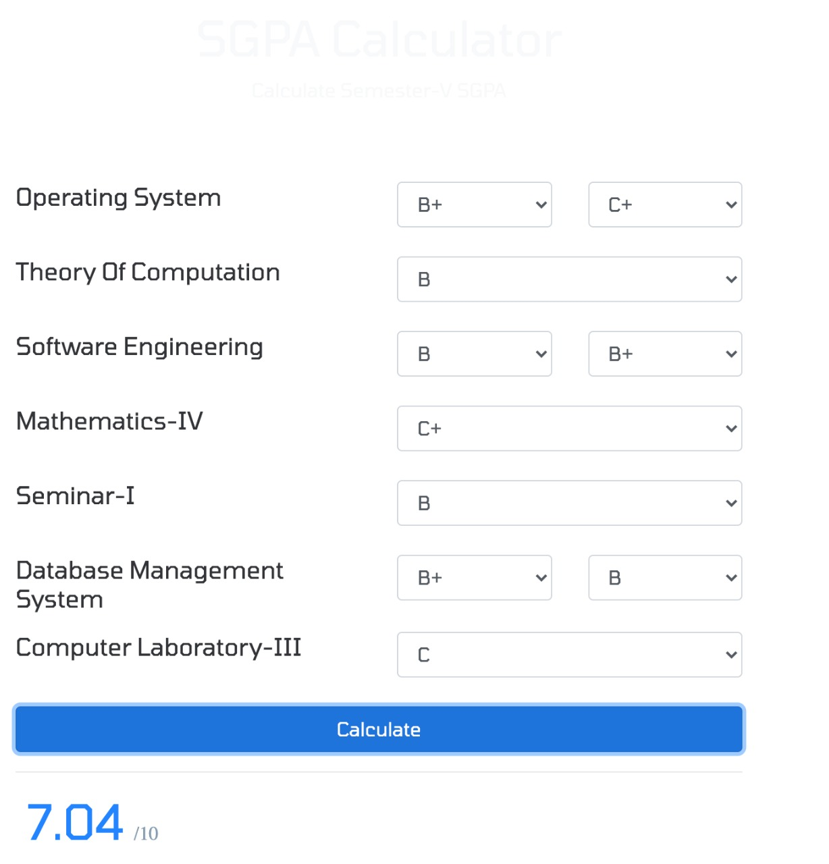

BIBLIOGRAPHY

- https://www.w3schools.com

- https://www.geeksforgeeks org

- https://freefrontend.com

- https://css-tricks.com/

- https://www.takeiteasyengineers.com

- https://dev.to/mychi_darko/php-tips-and-tricks-4kpn

